What is Community-Led Action Research and how is it done?

Copyright images © Photosymbols. Prepared by Scottish Community Development Centre

Introduction
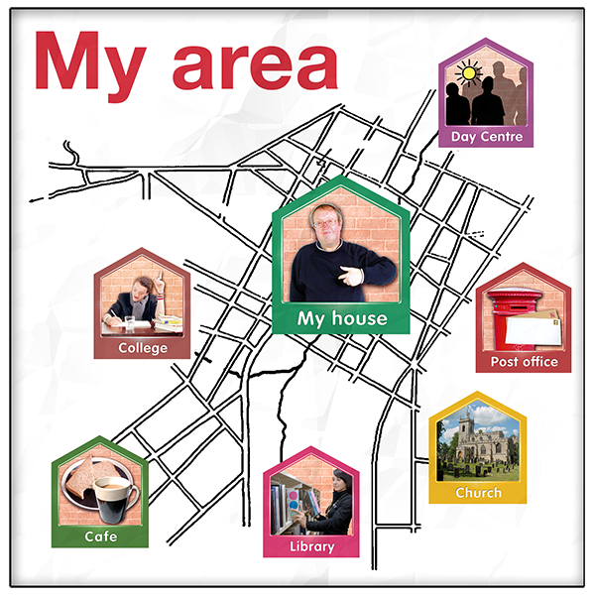 | Community is a group of people who live in an area or who have something in common.  Services sometimes talk about geographical communities, communities of interest and communities of identity.  A geographical community is a group of people who live in an area. That could be a town, a village or a country.  A community of interest is a group of people who share hobbies or who do similar things like a fishing group or an online gaming group.  A community of identity is a group of people who have things about themselves in common like disability, sex, gender, race or religion.
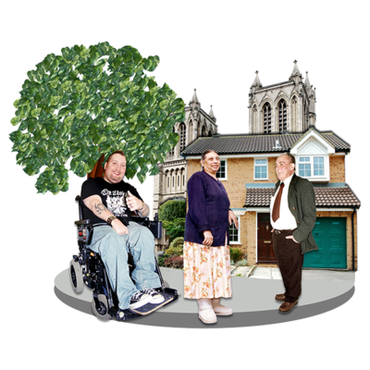 | Community-led is when people in a community work together to make things better for their community.  They decide what they want to make better, how they will find out more about it and carry out the research themselves.
 | Research means bringing information and experiences together in an organised way.
 | Action Research means that the research is used to make things better in a community.
In community-led action research, the knowledge and experience of communities is seen as most important.

Communities usually carry out the research themselves rather than getting an expert to do it.

Sometimes they might ask an expert to help them, but it is the community who are in charge.

 | An “expert” might be someone from a university or someone who is paid to do research.
There are lots of steps to community-led action research:

- Identify an issue or concern

- Plan how you will do your research

- Collect the information and analyse it

- Plan what can be done to make things better – the actions

- Carry out the actions

- Think about what happened as a result of the actions and if there is anything else that needs to be done
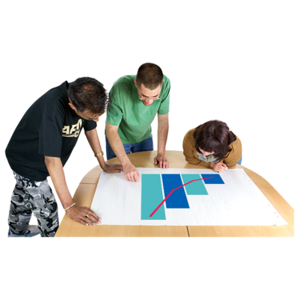 | Analyse means to look closely at something to understand more about it.  In research you might look at whether a lot of people are saying the same thing, or whether one group of people find things much harder than the rest.  You might think about the reasons for this.

An example of how community-led action research can work

Identify an issue or concern

People in our community have said that getting childcare is an issue.

We want to find out how big a problem this is and be able to show how things could be made better.

Plan how you will do your research

We want to find out how big a problem this is and find out what sort of childcare that people need.

We have planned to speak to people in the community.

We want to know what childcare people use now. This includes:

- Nurseries and childcare centres

- Childminders

- Family and friends who help look after children.

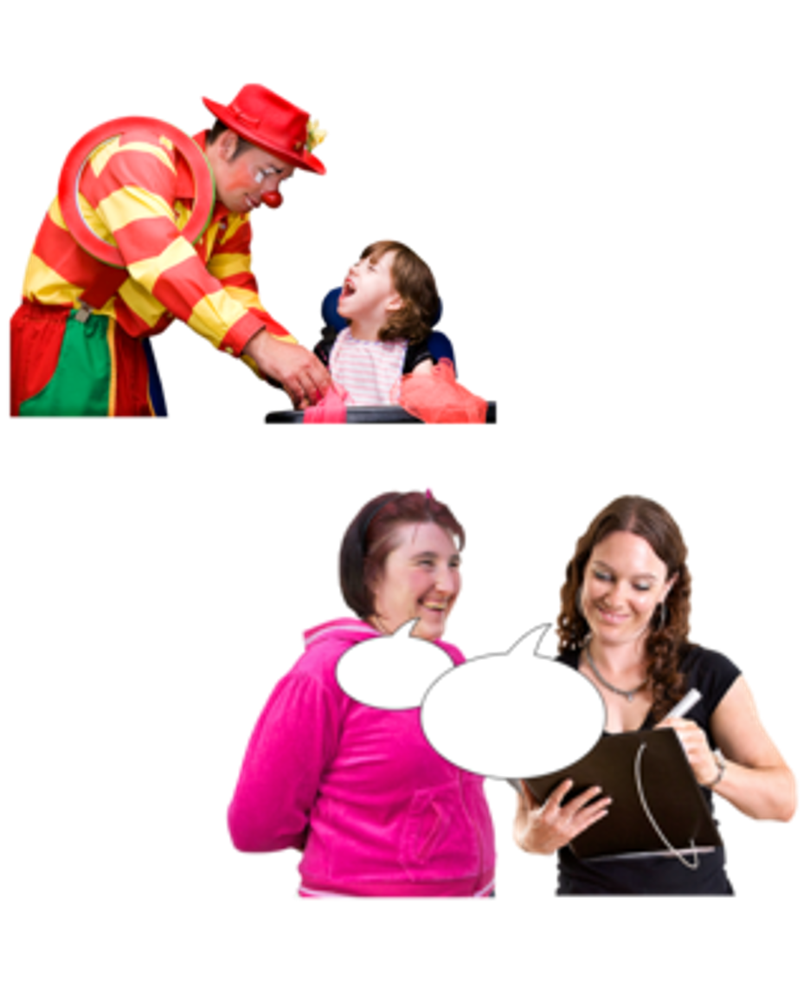 | Collect the information and analyse it  We have identified some people we want to speak to.  We will also interview people at the local gala day.  The gala has activities that the children can do while we speak to their parents.  We will also speak to local childcare centres to find out what they offer.
What  We  Found  Out | Share the information  Once we have spoken to people, we will analyse it to see if lots of people are saying the same thing.  We will see if any groups of people have bigger childcare problems than others.  We will put this information on a poster and share it with the community.

Plan what can be done to make things better – the actions

People have told us that a “drop-in” creche would be most useful.

“Drop-in” means you can use it when you need it.

We will look at starting a drop-in creche in the community centre.

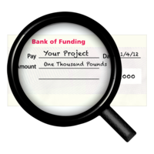  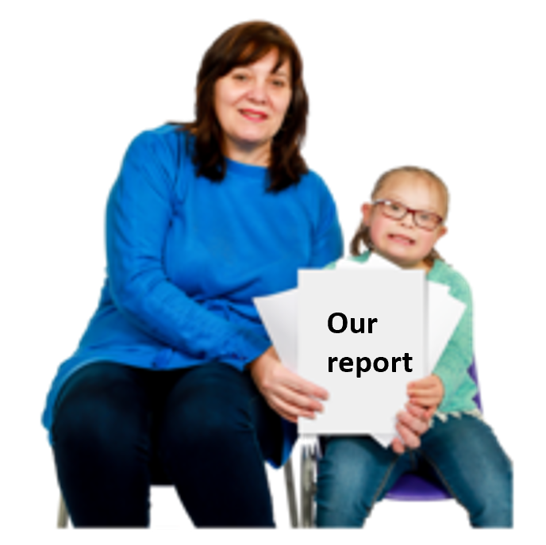 | Carry out the action  We applied for funding to set up a creche.  We used the information we found out in our research to show the funders that a creche was needed.  We set up the creche and advertised it in the community.  We invited local people to get involved in running it.  We are also using the information we found out in our research to show the local council that more childcare is needed.
Reflect and evaluate

We are going to think about what we have done and how we have made things better.

We will talk to group members about anything they think we could do differently next time.

We will look at what we can do next.

More information about Community-led Action Research

We have more information on our website.

To find out more about:

- Resources to help you, click here

- Training on how to do community-led action research, click here

To contact Scottish Community Development Centre:

E-mail info@scdc.org.uk

Or telephone 0141 248 1924

